Team Fist 2 Five

John Commander, John Giglio, Bill McGill & Jeff Box

Proposal:

Using data provided by the US Government on the top causes of death in the United States, we plan to provide a website that allows users to explore the changes year of year of cause of death data per state, providing a map that allows the user to filter over multiple parameters including year, state, and cause of death, along with graphs displaying time series data, tree maps, and bar charts to help visualize and understand the dataset, providing a clear picture of how the leading causes of death in the United States have been changing over time.

Dataset:

<https://catalog.data.gov/dataset/age-adjusted-death-rates-for-the-top-10-leading-causes-of-death-united-states-2013>

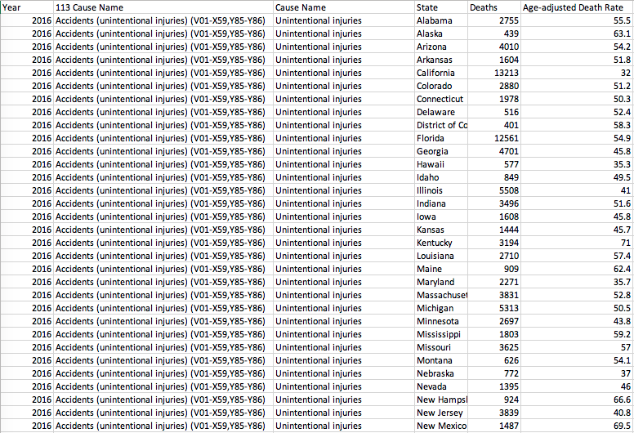

This is the dataset we will be using, which shows Year, the Cause of Death, State, Deaths, & Age-Adjusted Death Rate

Visualizations:

We will be using a Tree Map to display data for states and causes of death to show the proportion of a given cause of death. An example of a Tree Map: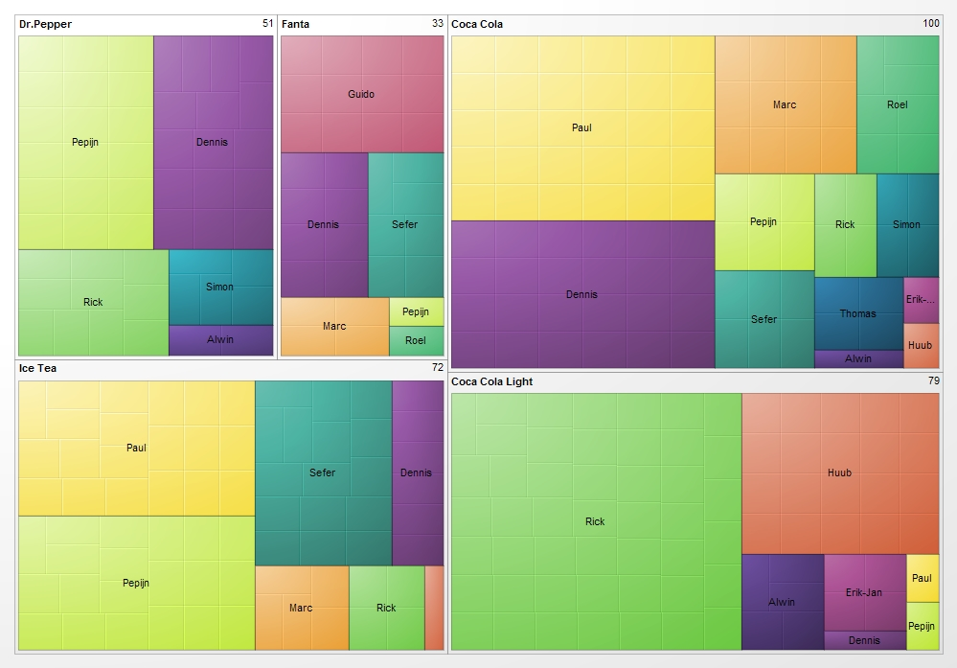

Along with Bar Charts that can be filtered between year, state and cause of death:

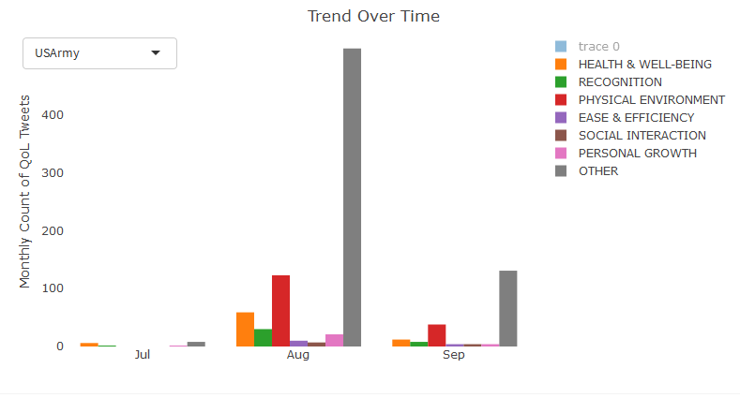

We would also be providing a map that can be filtered to show top causes of death for each state and the distribution of causes of death for each state. We are even planning on potentially adding a function that would link a user to websites that could provide advice on the prevention of the leading causes of death in the U.S.



Our final website design will look roughly like this:





